Power2Create

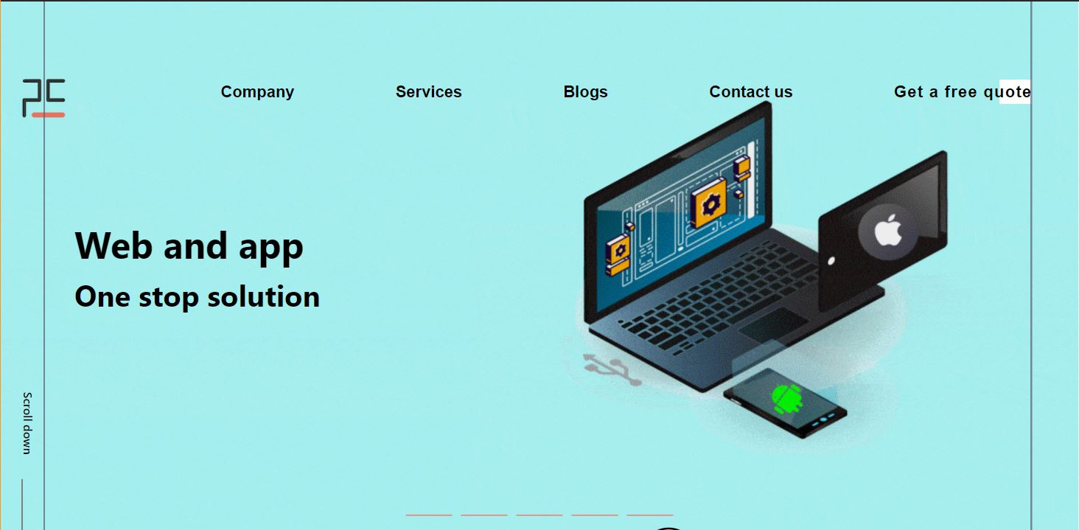

|  |  |  |  |
| --- | --- | --- | --- |
| **Container 1** | | | |
| **Part** | **Screenshot** | **Effect** | **Code** |
| 1. Logo |  | On hover, logo interchange.  On hover, Power2Create full logo will appear. | Reference:  HTML: Index.html line no. 79  CSS: Style.css line no. 160 |
| 1. Nav Bar |  | On hover, text color changes to brand color, position changes towards upward, width and font-size increases and bottom border appears. | Reference:  HTML: Index.html line no. 78  CSS: Style.css line no. 316 |
| 1. Banner |  | Five banners which will slide after a particular interval or by clicking on the lower button. | Reference:  HTML: Index.html line no. 112  CSS: Style.css line no. 88  Js: Script.js |
| 1. Banner Heading |  | Each banner contains a heading which will appear with a transition. | Reference:  HTML: Index.html line no. inner every myslide div. Banner heading div.  CSS: Style.css line no. 441 |
| 1. Scroll Down |  | On hover, it will change position and go down.  On click, page will scroll to next container. | Reference:  HTML: Index.html line no. 246  CSS: Style.css line no. 366 |

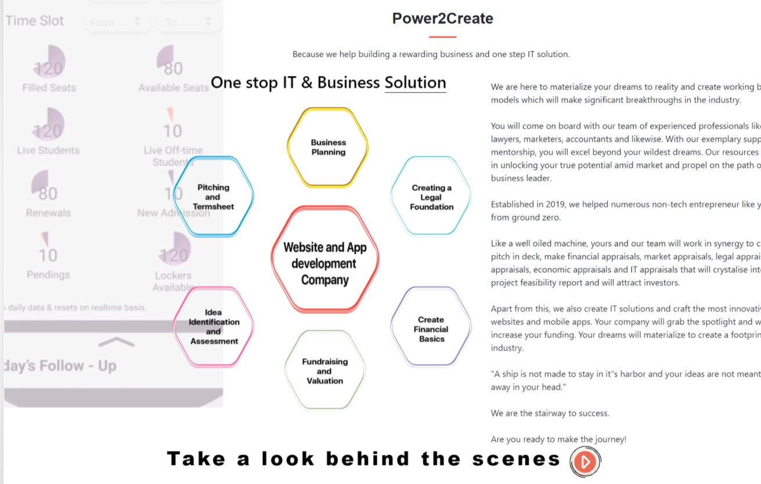**Container-2**

|  |  |  |  |
| --- | --- | --- | --- |
| **Container 2** | | | |
| **Part** | **Screenshot** | **Effect** | **Code** |
| 1. Main Heading |  | None | Reference:  HTML: Index.html line no. 246  CSS: Container-2.css line no. 32 |
| 1. Background video |  | On scroll Video will appear and play in background. | Reference:  HTML: Index.html line no. 269  CSS: Container-2.css line no. 72 |
| 1. xyz |  | On scroll icons will appears from center icons and start rotating around it. | Reference:  HTML: Index.html line no. 271  CSS: Container-2.css line no. 123  Js: C-2.js line no. 3 |
| 1. Bottom text |  | On hover, text will get underlined. | Reference:  HTML: Index.html line no. 317  CSS: Container-2.css line no. 914 |
| 1. Play button |  | On hover, the animation around the button will stop.  On click, a video will start playing on full window. | Reference:  HTML: Index.html line no. 322  CSS: Container-2.css line no. 783  Js: C-2.js line no.55 |
| 1. Right Paragraph |  | None | Reference:  HTML: Index.html line no. 288  CSS: Container-2.css line no. 725 |

**Container-3**

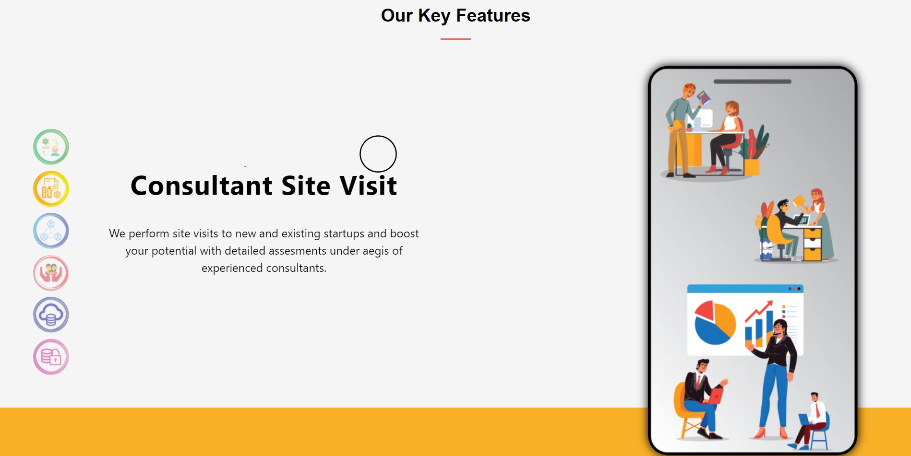

|  |  |  |  |
| --- | --- | --- | --- |
| **Container 3** | | | |
| **Part** | **Screenshot** | **Effect** | **Code** |
| 1. Main Heading |  | None | Reference:  HTML: Index.html line no. 368  CSS: Container-3.css line no. 08 |
| 1. Icons |  | On click icon will active and appears corresponding details and image. | Reference:  HTML: Index.html line no. 499  CSS: Container-3.css line no. 93  Js: C3-slider.js |
| 1. Details |  | Automatically appears from top with animation.  on Click previous slide will appear. | Reference:  HTML: Index.html line no. 376 in every Content-div-C3 div ->text-div  CSS: Container-3.css line no. 55  Cursor effect: In cursor arrow image |
| 1. Images |  | Automatically appears with animation.  on Click next slide will appear. | Reference:  HTML: Index.html line no. 387 in every Content-div-C3 div ->C3-img  CSS: Container-3.css line no. 208  Cursor effect: In cursor arrow image |

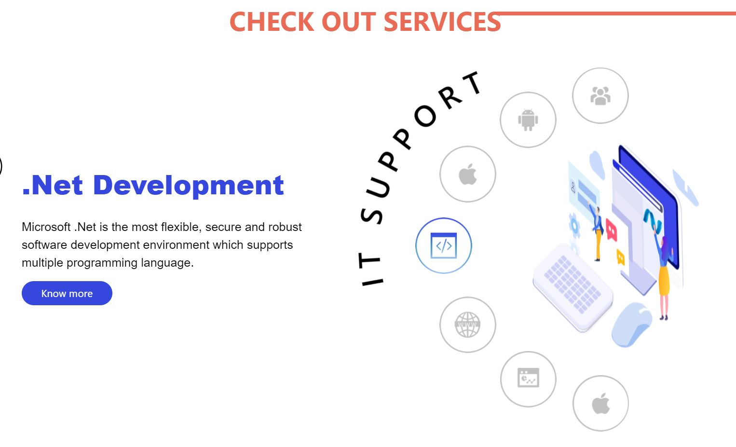**Container-4**

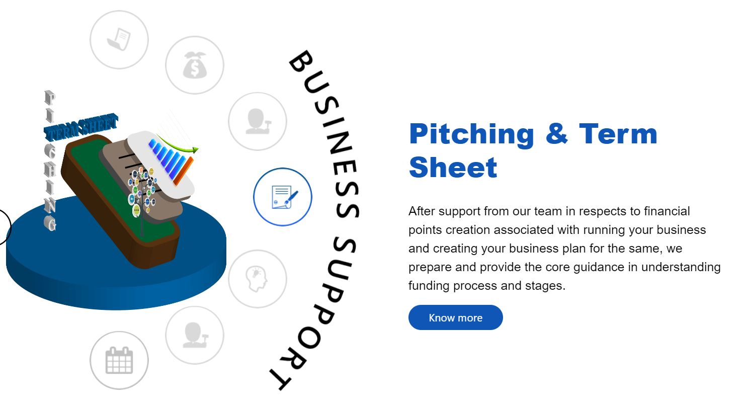

|  |  |  |  |
| --- | --- | --- | --- |
| **Container 4 – IT Service** | | | |
| **Part** | **Screenshot** | **Effect** | **Code** |
| 1. Main Heading |  | None | Reference:  HTML: Index.html line no. 531  CSS: Container-4.css line no. 14 |
| 1. Details |  | Automatically appears with animation.  on Click button know more land you It services page.  And on hover button shadow. | Reference:  HTML: Index.html line no. 541 Every Content div have div-text  CSS: Container-4.css line no. 278  Js: C4.js |
| 1. Animated icons and image |  | Image Automatically appears with animation from right.  on Click on icons corresponding to image and details will appears.  And on hover on icons visibility color will appear on icons.  And curve text rotates like pendulum continuously. | Reference:  HTML: Index.html line no. 538 Every Content div have image content and small circle.  CSS: Container-4.css line no. 351  Js: C4.js |
| **Container 4 – Business Support** | | | |
| 1. Details |  | Automatically appears with animation.  on Click button know more land you It services page.  And on hover button shadow. | Reference:  HTML: Index.html line no. 678 Every Content-div-Business have div-text-2  CSS: Container-4.css line no. 290  Js: C-4-II.js |
| 1. Animated icons and image |  | Image Automatically appears with animation from right.  on Click on icons corresponding to image and details will appears.  And on hover on icons visibility color will appear on icons.  And curve text rotates like pendulum continuously | Reference:  HTML: Index.html line no. 531 Every Content div have image content and small circle business  CSS: Container-4.css line no. 382  Js: C-4-II.js |

**Container-5**

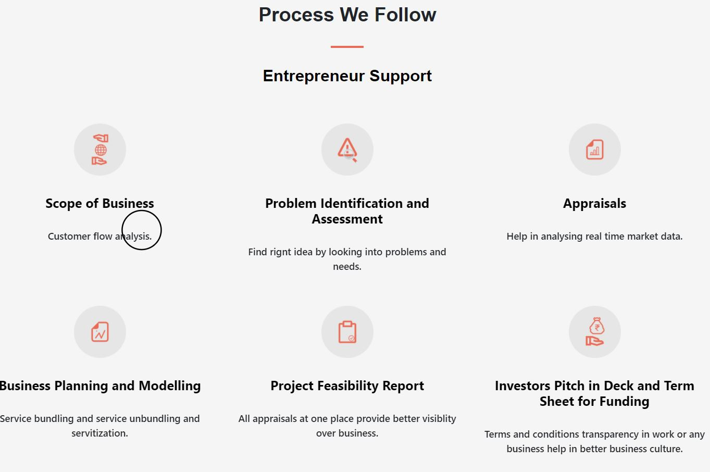

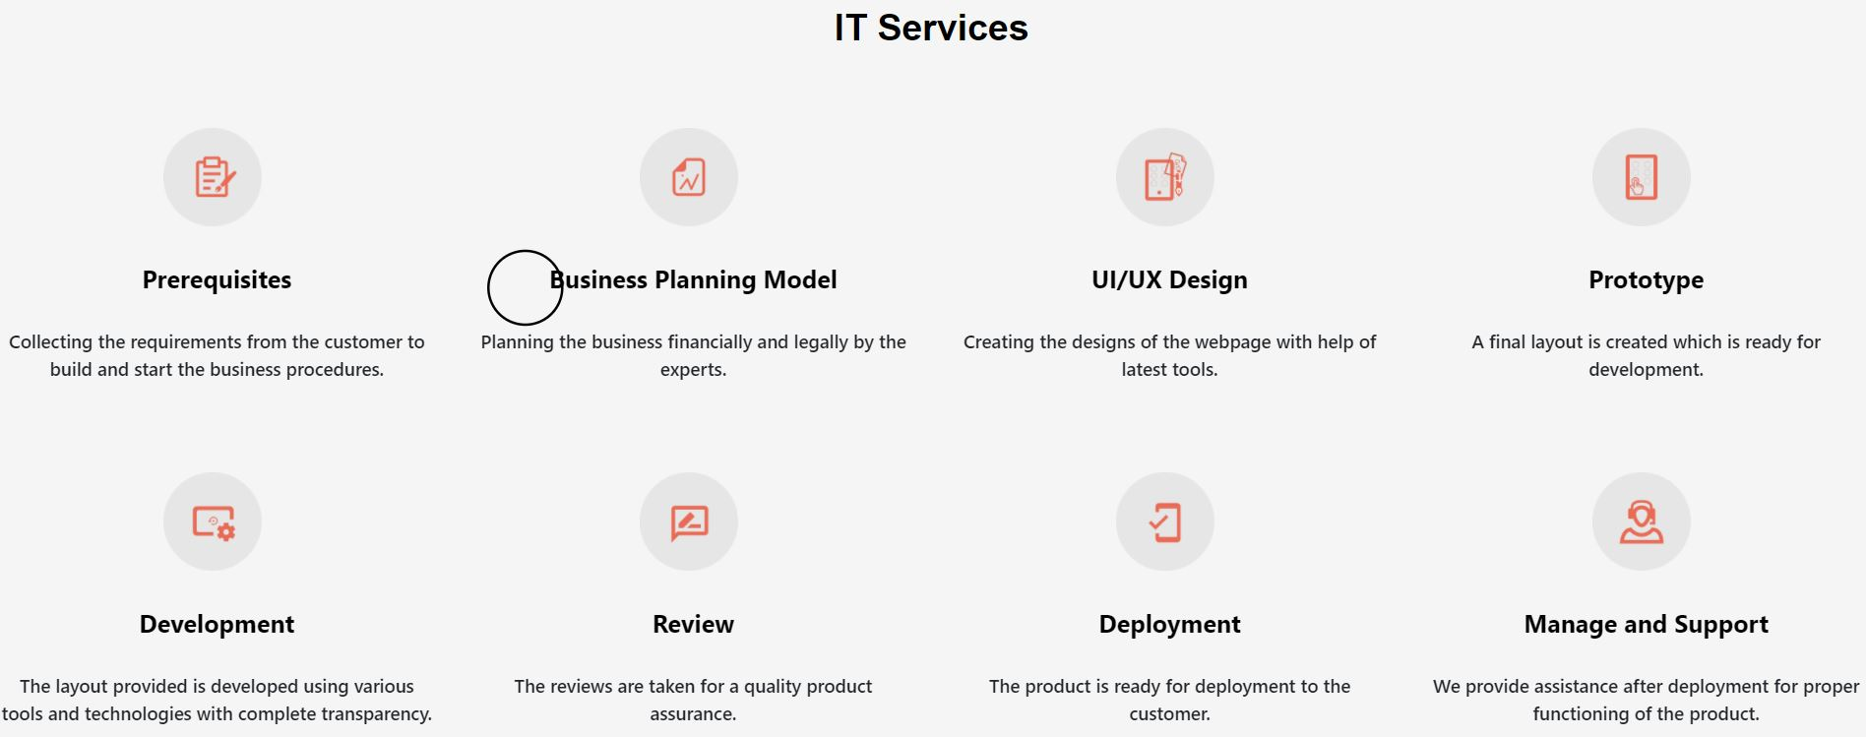

|  |  |  |  |
| --- | --- | --- | --- |
| **Container 5 - Entrepreneur Support** | | | |
| **Part** | **Screenshot** | **Effect** | **Code** |
| 1. Main heading |  | None | Reference:  HTML: Index.html line no. 799  CSS: Container-5.css line no. 11 |
| 1. Icons with details |  | None | Reference:  HTML: Index.html line no. 808 Every C-5-block have image and details text  CSS: Container-5.css line no. 51,68 |
| **Container 5 - IT Support** | | | |
| 1. Icons with details |  | None | Reference:  HTML: Index.html line no. 850  CSS: Container-5.css line no. 112 |

**Container-6**

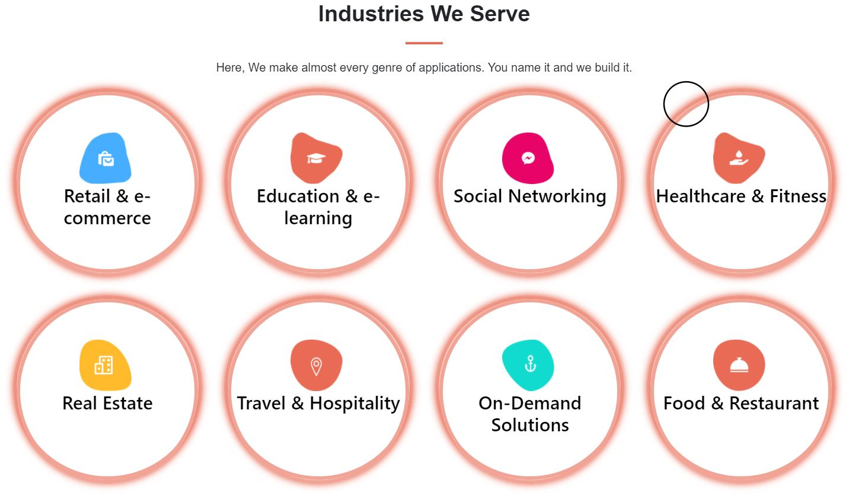

|  |  |  |  |
| --- | --- | --- | --- |
| **Container 6** | | | |
| **Part** | **Screenshot** | **Effect** | **Code** |
| 1. Main heading |  | None | Reference:  HTML: Index.html line no. 908  CSS: Container-6.css line no. 05 |
| 1. Icons with Details |  | On hover Flip rotate along Center axis | Reference:  HTML: Index.html line no. 928 Every Flipper Container have front and back.  CSS: Container-6.css line no. 72 |

**Container-7**

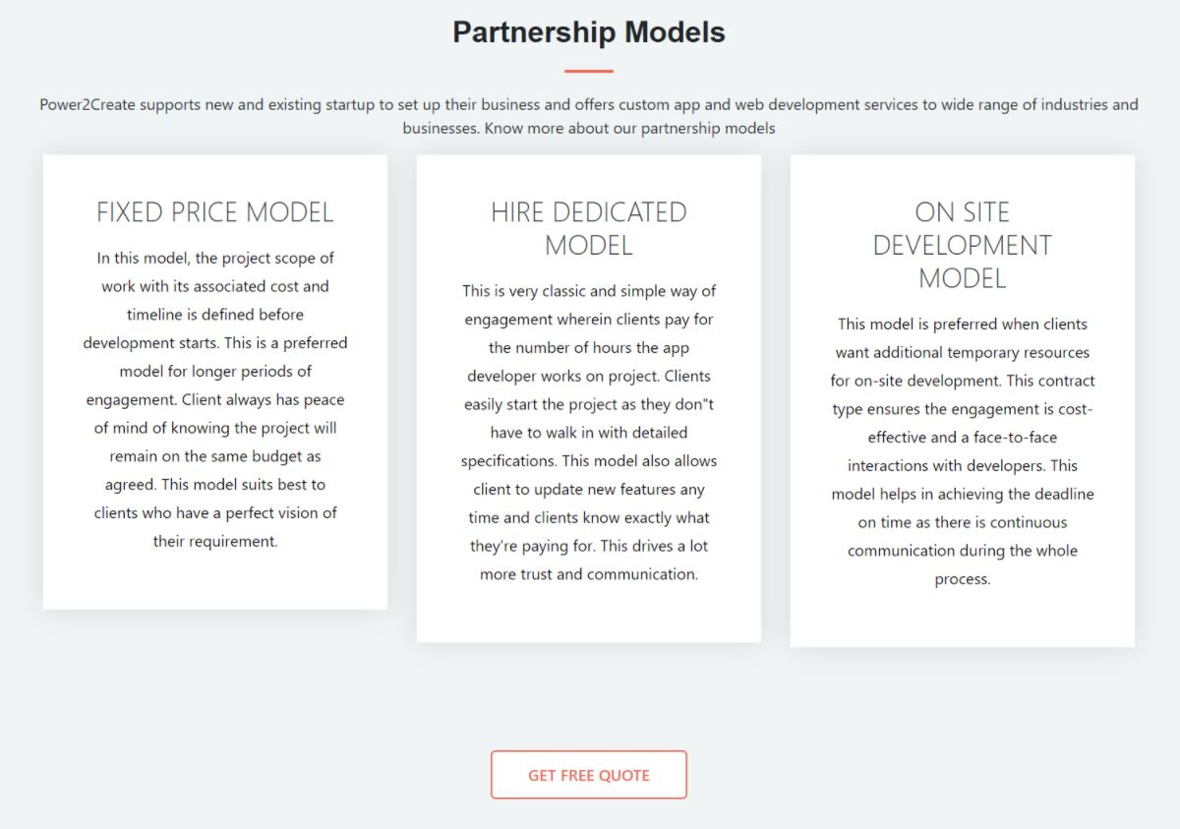

|  |  |  |  |
| --- | --- | --- | --- |
| **Container 7** | | | |
| **Part** | **Screenshot** | **Effect** | **Code** |
| 1. Main Heading |  | None | Reference:  HTML: Index.html line no. 1091  CSS: Container-7.css line no. 07 |
| 1. Heading with details |  | None | Reference:  HTML: Index.html line no. 1098 Every C8-content-div have heading and details div.  CSS: Container-7.css line no. 45 |
| 1. Button |  | On hover button fill with brand color. | Reference:  HTML: Index.html line no. 1116  CSS: Container-7.css line no. 83 |